Excel Macros.

This document shows how to setup Macros in Excel that are for use anytime you open up Excel, they are not connected to a specific workbook.

This shortcut is to add the below macro subroutine to a personal.xlsm file for the EXFO Macro.

**The Macro is between the lines below**

------------------------------------------------------------------

Sub LinkToEXFOMacro()

'

' LinkToEXFOMacro Macro

Workbooks.Open Filename:= _

"http://usq2qap114.commscope.com:81/stellent/dasoftware/SoftwareDataAnalysisMacros/EXFOSummaryMacro.xlsm"

End Sub

Then we will add a run Icon to your Quick Access toolbar

Below is an image of My Quick Access Toolbar.

If you know how to do this go ahead but use this ICON otherwise I can set it up really quick with this email.

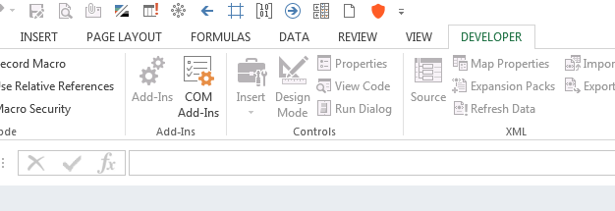

The basic steps are.

If you do not have the DEVELOPER tab you will have to add it.

Under Excel Options click Add-ins

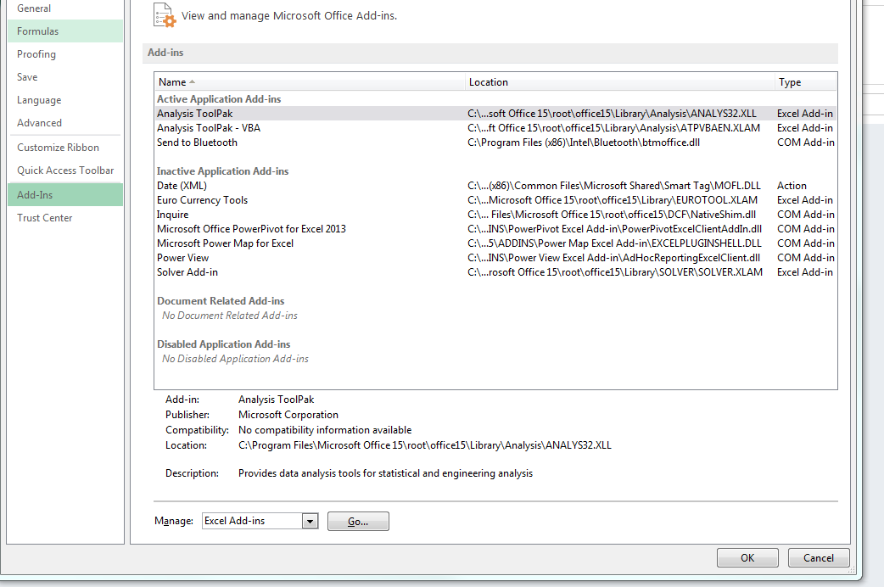

Then on the bottom under Manage: pull down and select Excel Add-ins, Click Go

You will get this pop-up

Select Analysis ToolPack and Analysis ToolPack- VBA

Click OK.

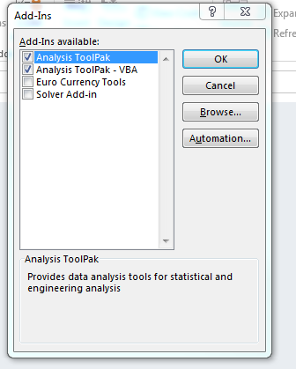

To see the Developer tab you need to right click on a tab select customize Ribbon and check the Developer box on the pop-up below.

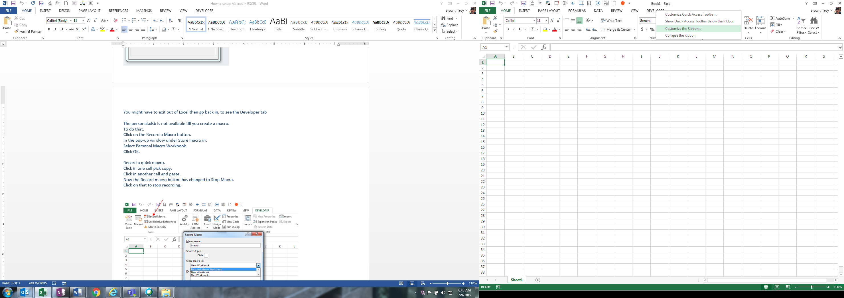

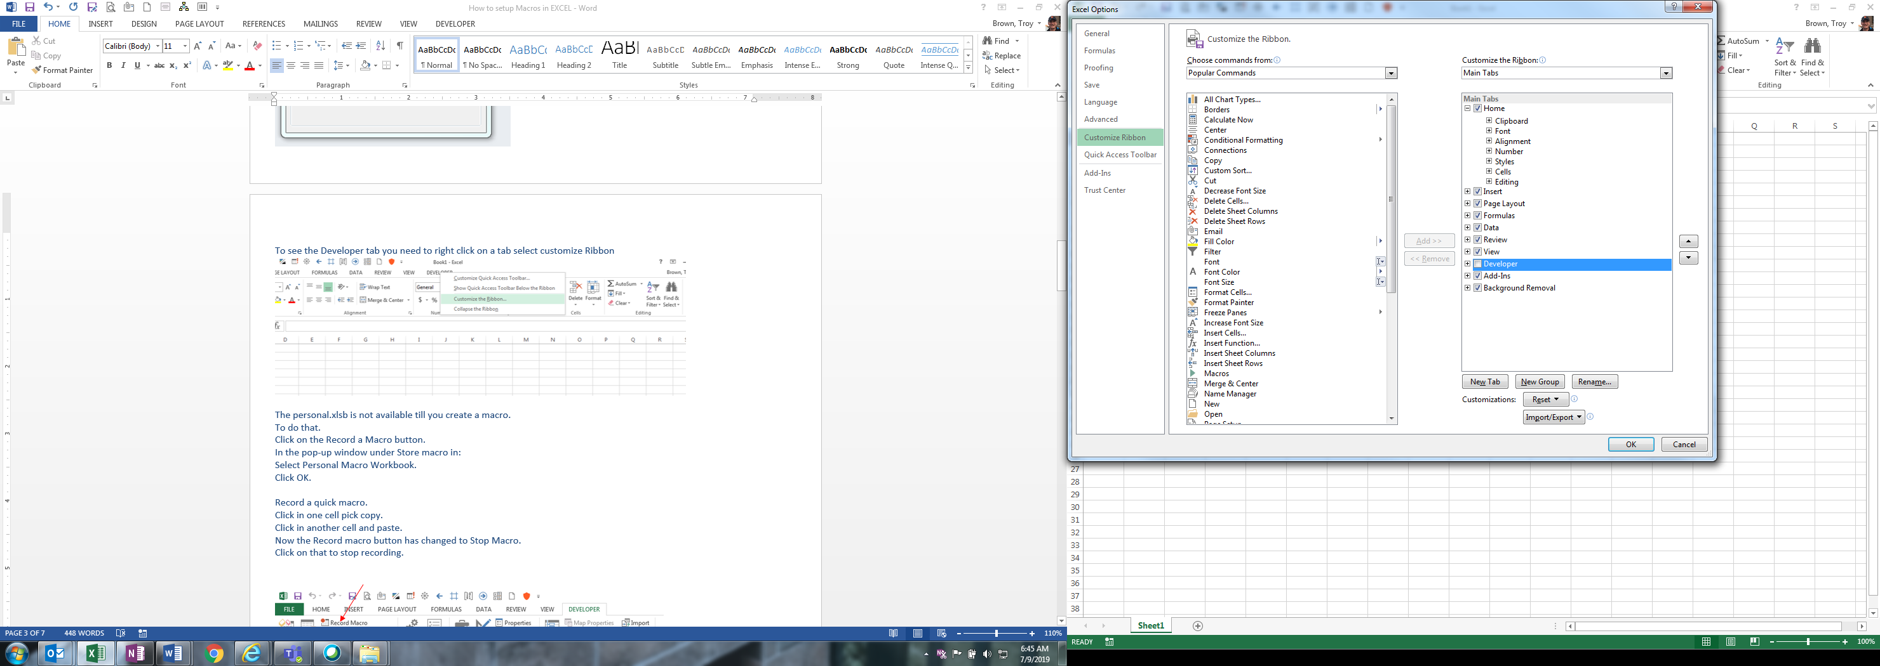

The personal.xlsb is not available till you create a macro.

To do that.

Click on the Record a Macro button.

In the pop-up window under Store macro in:

Select Personal Macro Workbook.

Click OK.

Record a quick macro.

Click in one cell pick copy.

Click in another cell and paste.

Now the Record macro button has changed to Stop Macro.

Click on that to stop recording.

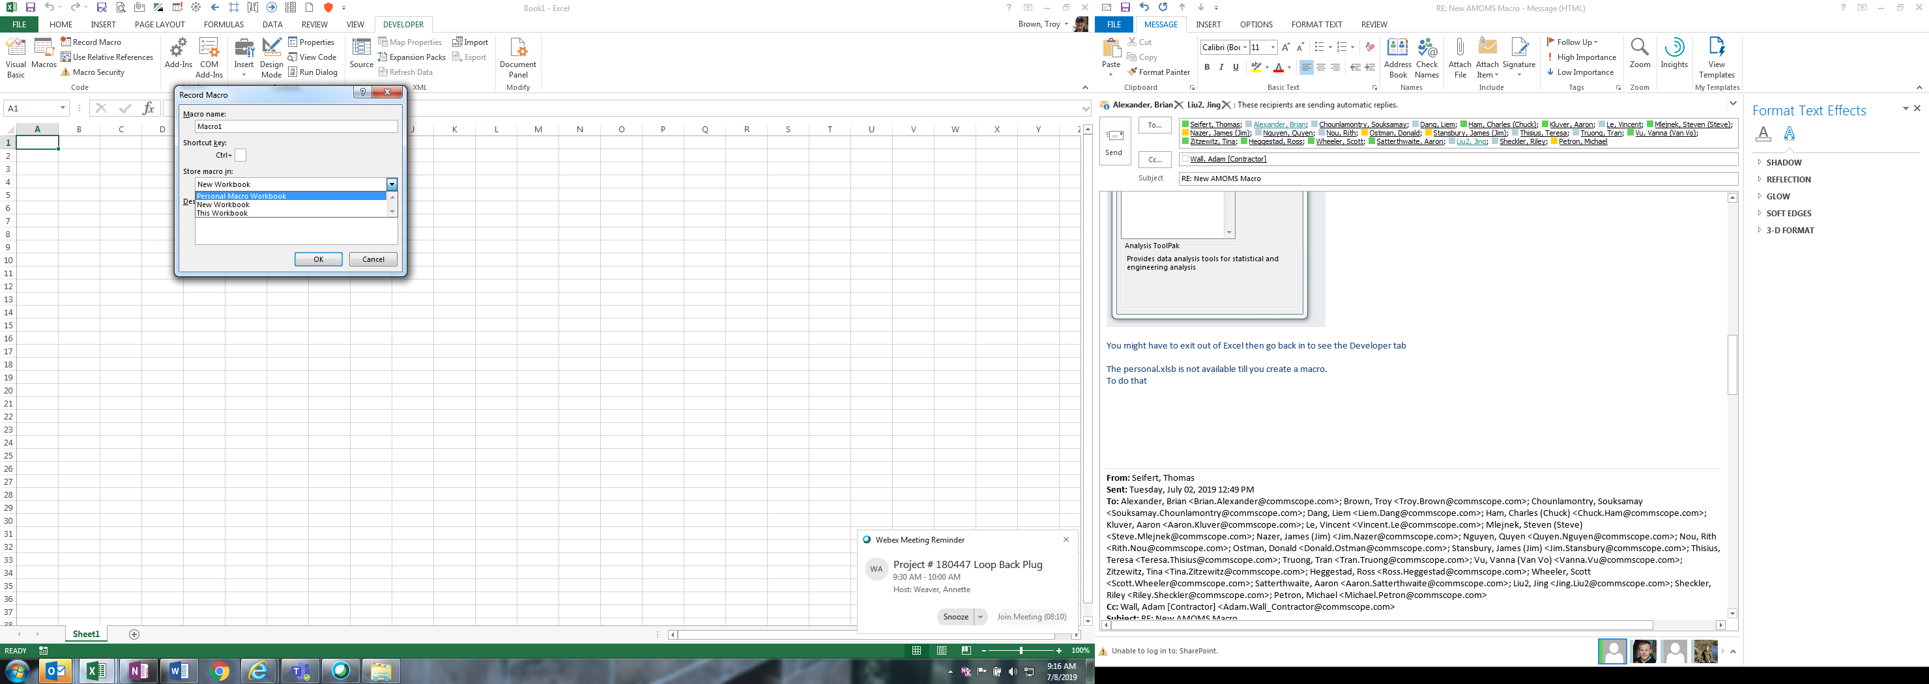

Click on the Visual Basic Icon and the VBA window will pop up.

It should look similar to this below.

You will see under VBAProject (Personal.XLSB)

A Modules folder and below that is Module 1 (I got a lot more in mine)

In the right window you will see the macro you recorded.

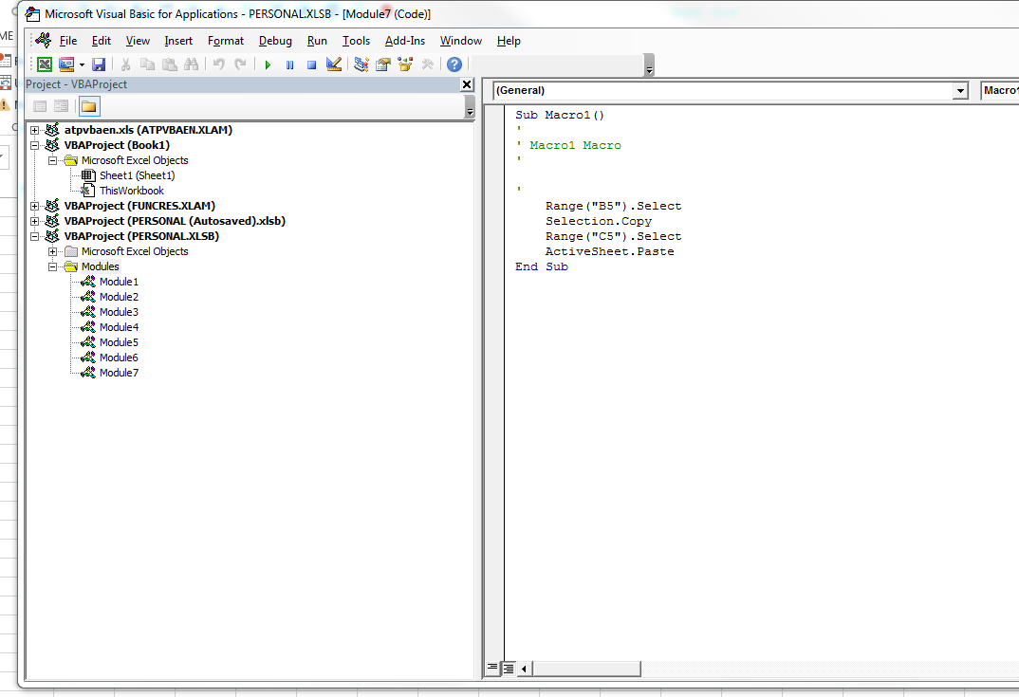

Now Delete that Text in the right window and copy and paste the Text from the top of this document.

So this should be what it looks like.

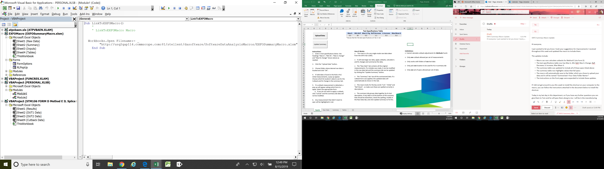

Now SAVE, use file save: File and Save Personal.XLSB

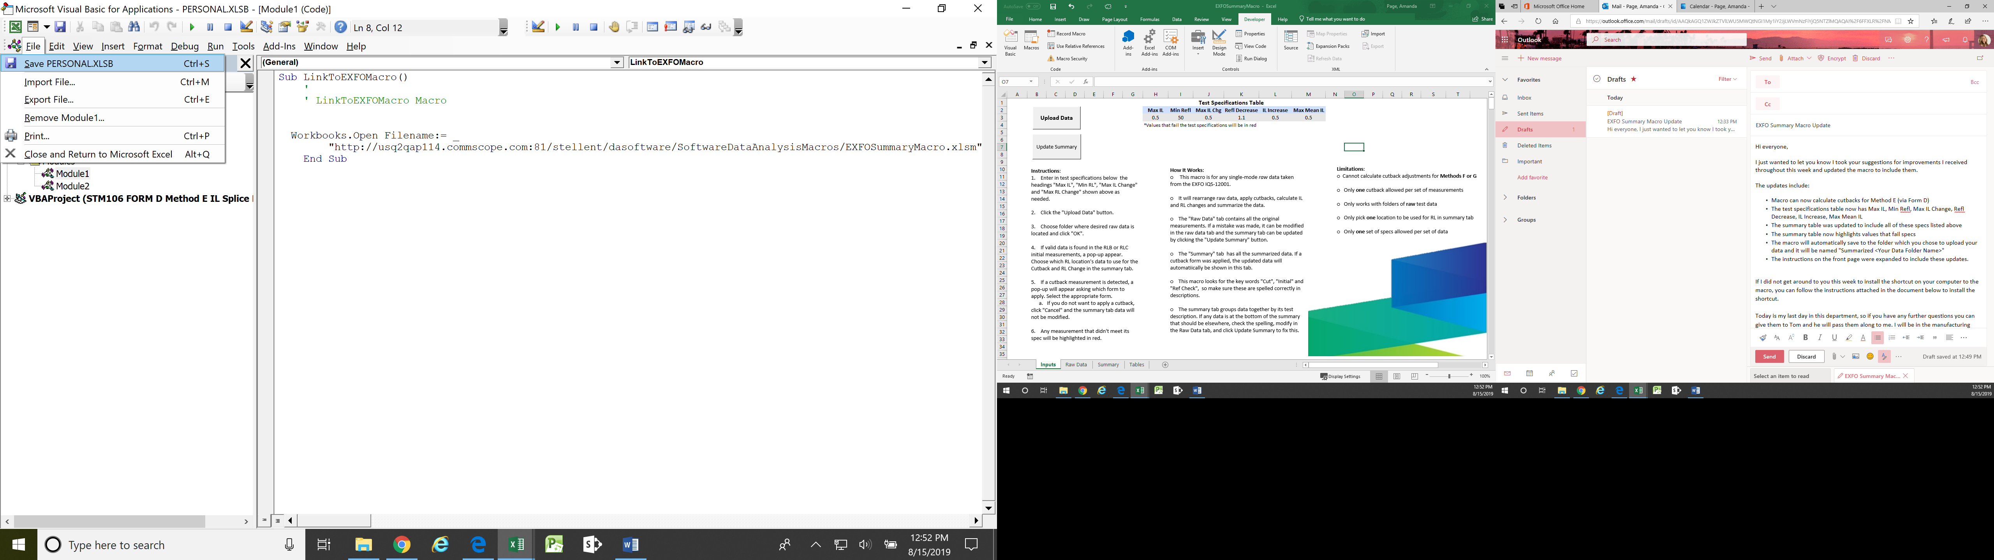

To get the link on your Quick Access Toolbar.

Right click on an Icon on the top and you should get the pop-up below.

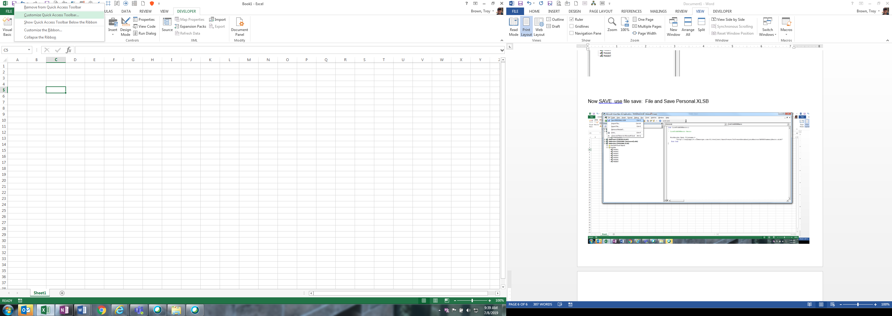

Select Customize Quick Access Toolbar, you will get this pop-up.

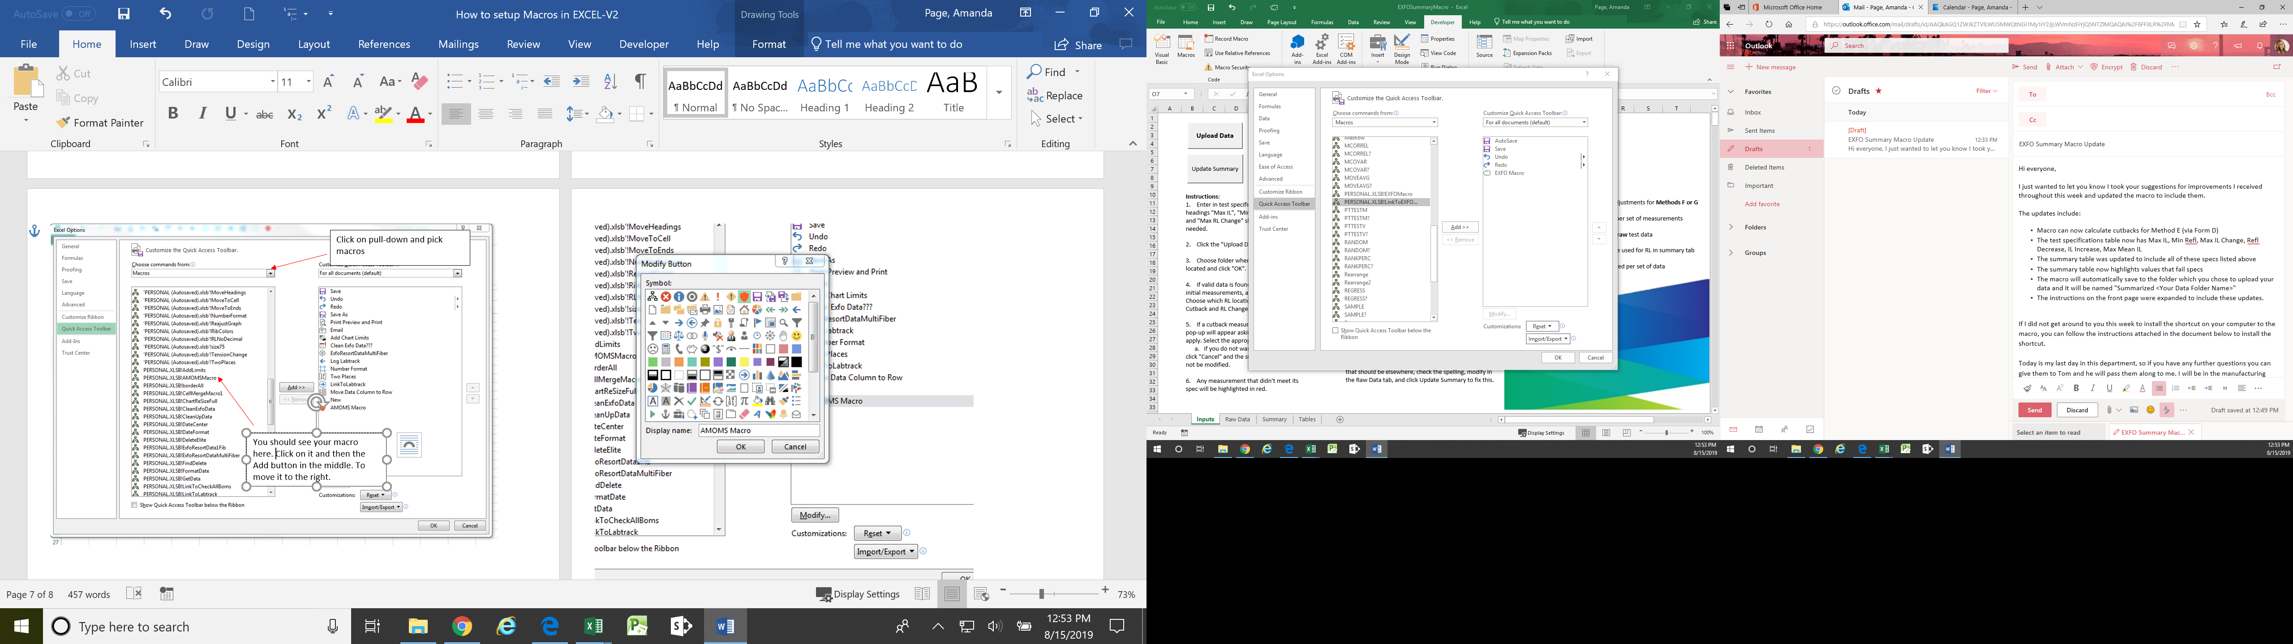

You should see your macro here. Click on it and then the Add button in the middle. To move it to the right.

Click on pull-down and pick macros

After you add the macro to the right list then you can modify the Icon and the Display name.



I picked this Cloud as the Icon and changed the Display Name to EXFO Macro, this is what you see if you hover over the Icon.

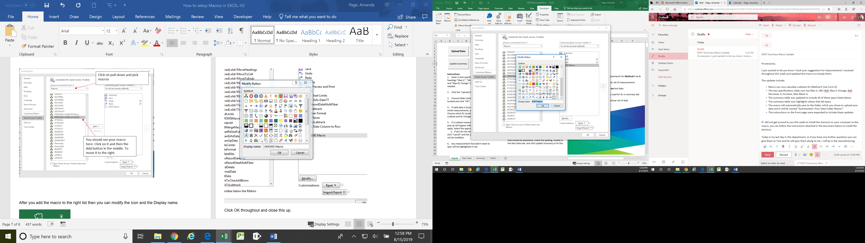

Click OK throughout and close this up.